**SOHAM TIWARI**

**OS LAB 2 CSE C 43 07/12/20 180905360**

**1. SIMULATE ls -l**

#include <unistd.h>

#include <stdio.h>

#include <sys/stat.h>

#include <sys/types.h>

#include<stdlib.h>

#include<dirent.h>

#include<time.h>

#include<pwd.h>

#include <grp.h>

#include<string.h>

int main(int argc, char **argv){

// struct group *gp;

DIR *mydir;

// char *c;

// int i;

struct dirent *myfile;

struct stat fileStat;

mydir=opendir(".");

stat(".",&fileStat);

while((myfile=readdir(mydir))!=NULL){

stat(myfile->d_name,&fileStat);

if(strcmp(".", myfile->d_name)==0 || strcmp("..", myfile->d_name)==0)

continue;

else{

printf("%s\n",myfile->d_name);

printf("File Permission: \n");

printf( (S_ISDIR(fileStat.st_mode)) ? "d" : "-");

printf( (fileStat.st_mode & S_IRUSR) ? "r" : "-");

printf( (fileStat.st_mode & S_IWUSR) ? "w" : "-");

printf( (fileStat.st_mode & S_IXUSR) ? "x" : "-");

printf( (fileStat.st_mode & S_IRGRP) ? "r" : "-");

printf( (fileStat.st_mode & S_IWGRP) ? "w" : "-");

printf( (fileStat.st_mode & S_IXGRP) ? "x" : "-");

printf( (fileStat.st_mode & S_IROTH) ? "r" : "-");

printf( (fileStat.st_mode & S_IWOTH) ? "w" : "-");

printf( (fileStat.st_mode & S_IXOTH) ? "x" : "-");

printf("\n");

}

}

closedir(mydir);

return 0;

}

OUTPUT:

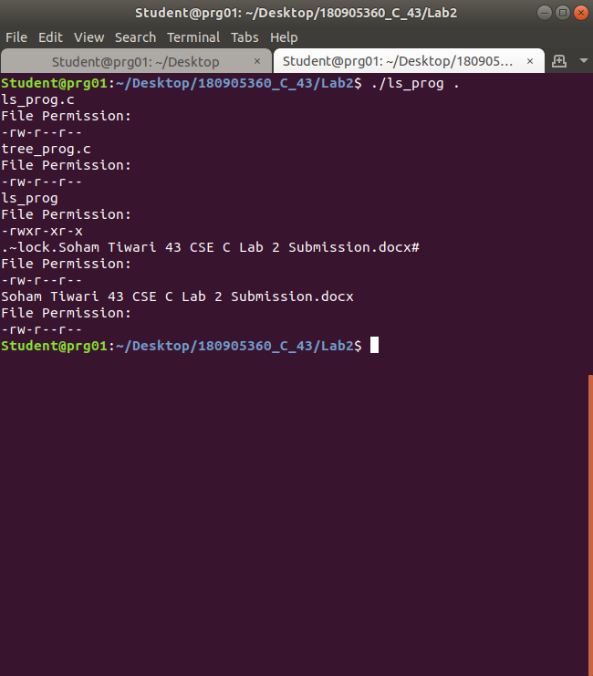

**2. SIMULATE tree .**

#include <unistd.h>

#include <sys/stat.h>

#include <stdlib.h>

#include <stdio.h>

#include <string.h>

#include <dirent.h>

void printdir(char * dir, int depth)

{

DIR* dp;

struct dirent* entry;

struct stat statbuf;

if((dp = opendir(dir)) == NULL)

{

fprintf(stderr, "cannot open directory: %s\n", dir);

return;

}

chdir(dir);

while((entry = readdir(dp)) != NULL)

{

lstat(entry->d_name, &statbuf);

if(S_ISDIR(statbuf.st_mode))

{

if(strcmp(".", entry->d_name)==0 || strcmp("..", entry->d_name)==0)

continue;

printf("%*s%s/\n",depth," ",entry->d_name);

printdir(entry->d_name, depth+4);

}

else

printf("%*s%s/\n", depth," ", entry->d_name);

}

chdir("..");

closedir(dp);

}

int main(int argc, char const *argv[])

{

/* code */

if(argc==2)

{

char *dir = (char*)argv[1];

printdir(dir, 0);

}

else

printdir("/home", 0);

printf("Exiting...done.\n");

// return 0;

exit(0);

}

OUTPUT:

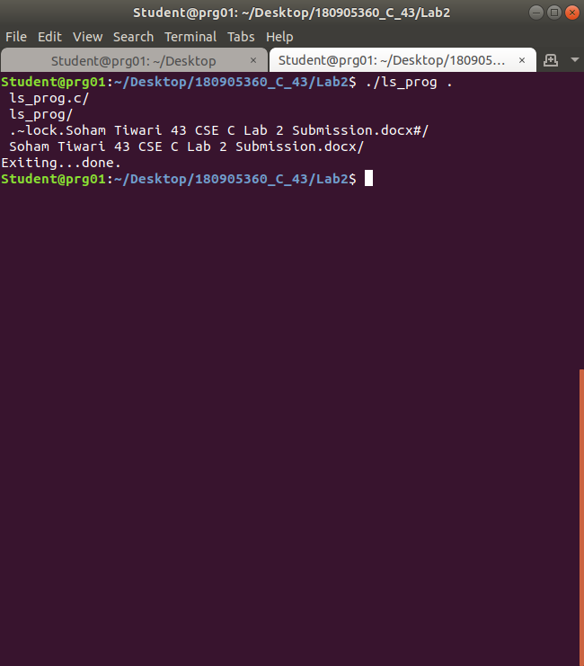

**3. LIST ALL INSTALLED PACKAGES**

apt list –installed

OUTPUT:

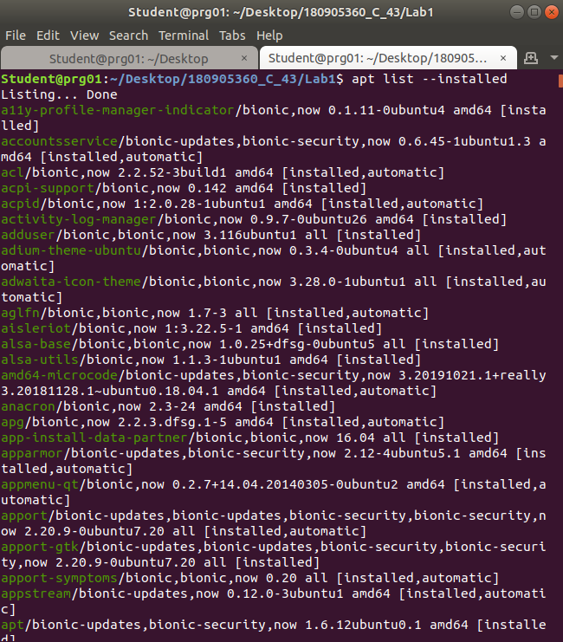

**4. LIST ALL INSTALLED RPM PACKAGES**

rpm -qa

OUTPUT:

(no rpm packages installed currently)

